Austin Stephens

Assignment 5

2/24/17

6-01.) My program successfully takes ten integers and then stores them all in an array. The program also outputs a menu asking if the user wants to sort the array in ascending or descending order. The menu is not functional.

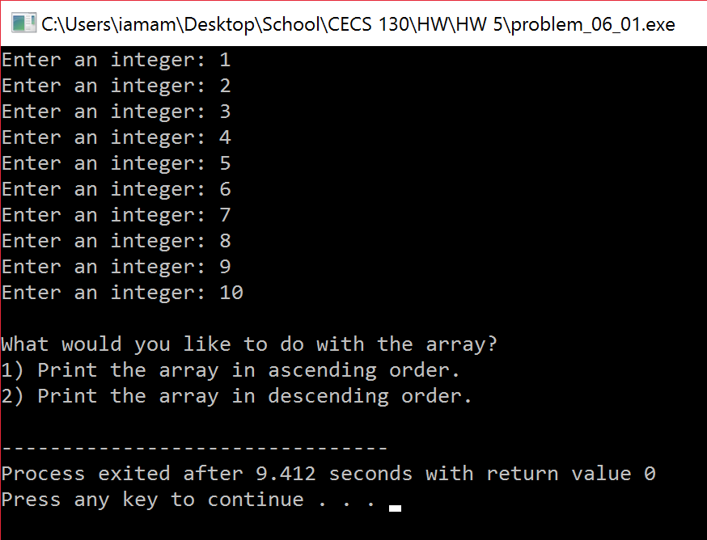

6-02.) My program successfully takes up to 30 GPAs as floats, stores them in an array, and calculates their average whenever the user is done entering the GPAs.

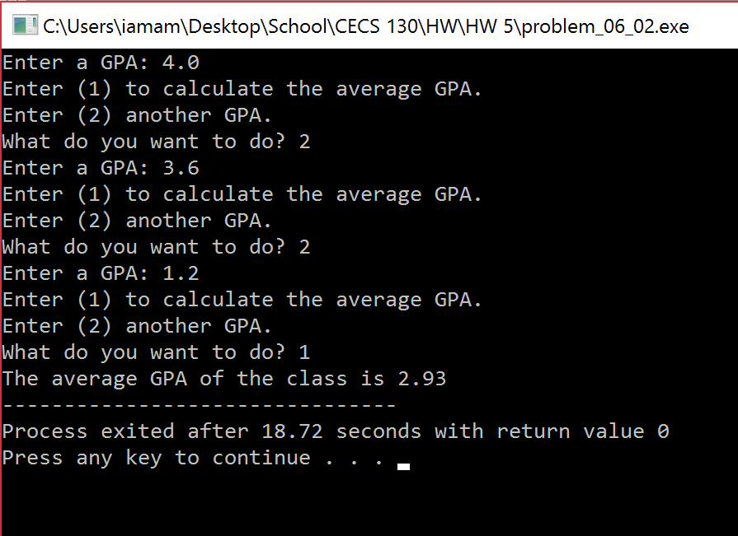

7-01.) My program successfully initializes an integer, character, and float as well as pointer values that point to those variables. It then prints the values of both the pointers and nonpointers and then prints the memory address of both the pointers and nonpointers.

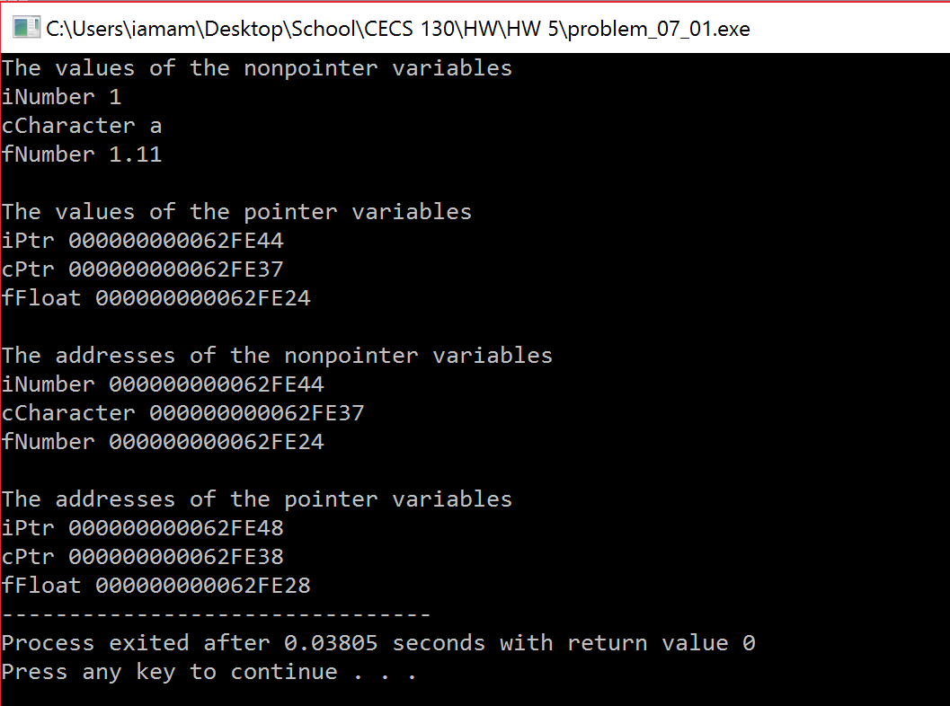

7-03.) My program successfully allows the user to input the amount of die he/she wants to roll up to 6, creates an array of that size, and then uses the TossDie() function to generate the random values for the dice and store them in the values array. The program then prints the values of all the dice.

